**CP Club 365Days Challenge**

**Date – 02/12/2022**

**Programming language – C++**

**Problem Statement**

**<https://www.hackerrank.com/challenges/luck-balance/problem?isFullScreen=true>**

**Your Code**:

// 0x46Day of 0x365Days challenge

// VEDANT BHARAD

// 02-12-2022

#include <bits/stdc++.h>

using namespace std;

int main() {

    int n, k;

    cin >> n >> k;

    int ans = 0;

    vector<int> a;

    for (int i = 0; i < n; i++) {

        int x, tp;

        cin >> x >> tp;

        if (tp == 0) { // if the importance is 0 then direct add the luck to ans

            ans += x;

        }

        else {

            a.push_back(x);

        }

    }

    sort(a.begin(), a.end() );

    reverse(a.begin(), a.end() );

    for (int i = 0; i < min((int)a.size(), k); i++) {

        ans += a[i];

    }

    for (int i = k; i < a.size(); i++) {

        ans -= a[i];

    }

    cout << ans << endl;

    return 0;

}

**Output (Screen Shot)**:

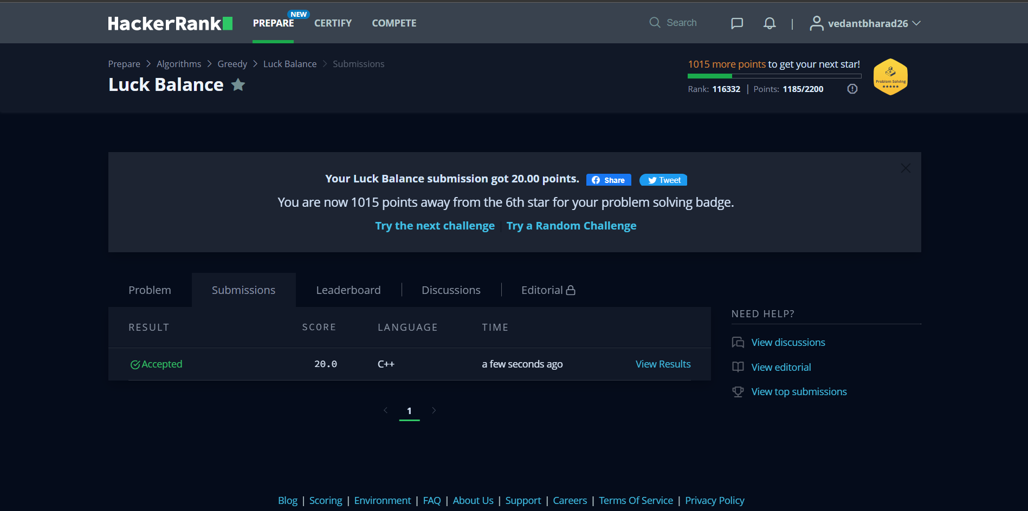

**Understanding about problem:**

1. In this task there are three input first is length of array second is k value and at last array it self
2. in this task first I need to sort an array and then also convert in reverse it then from 0 to min value of array length and k in need to sum all value of array and then from kth value to length of array I need to subtract the value of array from that sum.

Note: If you can't understand the problem, feel free to contact us and we'll help you. Please don't copy and paste from anywhere.

ALL THE BEST

Team CP Club